Task 4 (LO AC 4.1, 4.2, 4.3, 4.4, M1, M2, M3, D1, D2)

In your report:

4.1 Critically review and test your game. Analyse actual test results against expected results to identify discrepancies.

Unit Specification Guidance:

Testing methods: test strategy e.g. black box, white box, interface; iterative approach (testing at various stages of development); test plans and test cases; test logs; test evidence; test reports; retests done

Mechanisms: procedures e.g. checking valid declarations, debugging code, checking naming conventions, checking functionality against requirements, error detection, error messages, compiler errors, runtime errors, in code response, dry running

|  |  |  |  |
| --- | --- | --- | --- |
| **Test No.** | **Test** | **Test Data** | **The Result** |
| 1 | Clicking on run | “Click on run” | It starts the game. |
| 2. | Press Enter key to start the game | “Press the enter key” | The game starts at level 1. |
| 3. | Press W Key to accelerate | “Press the W key“ | The car drives forwards. |
| 4. | Press A key to turn left | “Press the A key” | The car turns left. |
| 5. | Press S key to reverse | “Press the S key” | The car drives backwards. |
| 6. | Press D key to turn right | “Press the D key” | The car turns right. |
| 7. | Drive into pedestrian | “Pedestrian” | The game stops for a split second and plays a crashing noise which leads into the game over screen. |
| 8. | Drive into enemy car | “Enemy car” | The game stops for a split second and plays a crashing noise which leads into the game over screen. |
| 9. | Drive to the other side of the screen | “Finish line” | The game starts on the next level of the game which allows the player to progress. |

The problems I have ran into the game is that when you fail the game then the music loop will continue but a new loop will start at the same time which means that you will hear twice the music which can be annoying for a lot of people. Another issue I have found within the game is level 3 as the cars and pedestrians don’t disappear off of the map like the rest of the levels do which means that there is something wrong in the code as it doesn’t do this on the other two levels.

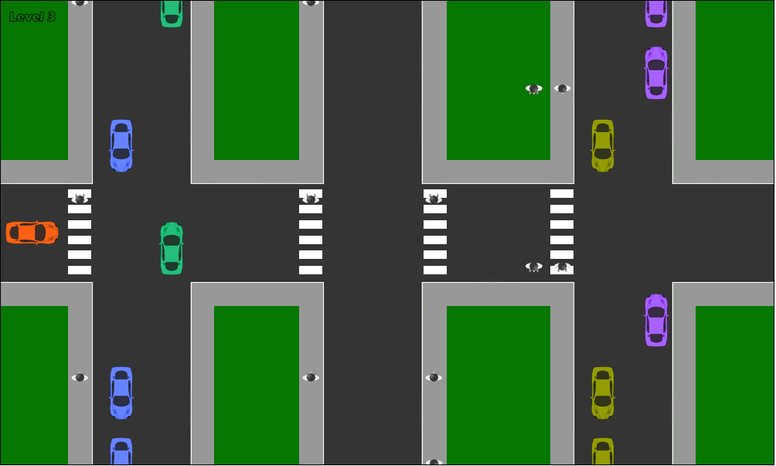

As you can see above the enemies do spawn but the enemies that are meant to disappear stay there which isn’t meant to happen and another problem is on the middle right where there are two pedestrians walking with each other which isn’t meant to happen, the other pedestrian is meant to be on the end part in order to make the level the most challenging out of the bunch.

However, despite running into these problems, the game is suitable for the target audience as it is a simple game and kids will love to drive a car but most of all, it will teach them how to drive responsibly and what to do and what not to do while driving, the game is simple but fun and that’s how I wanted to make it since it is intended for a young audience. It is also meant to improve their hand-eye coordination since they may have to react quick to certain situations such as making a quick turn or quickly drive past just before the enemy car can hit you. While it improves their hand-eye coordination, it will also increase in challenge as the levels go on and that’s what I wanted to give so then it doesn’t feel too easy for the kids to play or that it starts to feel the same so I wanted to add more enemies on screen so they can take their time to plan out how to tackle the level rather than rushing it and trying to complete it all in one go.

4.2 Critically evaluate independent feedback and make recommendations for improvements. Include quotes from peers.

Unit Specification Guidance:

Feedback: record feedback, e.g. surveys, questionnaire, interviews; analyse feedback; present results

Kayle Antoine’s Review

“The game runs really well, it is a great game for kids but there are a few bugs and glitches with the program such as the music still playing and another version of the song comes on so that needs to be fixed and the other problem is the cars don’t disappear on level 3 which makes it look out of place but other than these problems, it is easy for kids to pick this game up and enjoy it”.

If I were to improve the game based on this feedback I would sort out the code for the music as I think the code for the music has gone wrong and is placed in 2 parts of the game which is where the issue is and the other issue which is the buggy level 3, I would need to change the code or add something in the code for the cars to disappear because as the feedback says, it does look out of place and this can be improved by resolving the problem as the car disappearing would look like the cars are carrying on off the screen.

Carlton-Currie Bradley’s Review

“The game is well made and is a great game for kids to play around with. However, the music is really irritating due to that fact that when you fail, it will have two of them running at the same time, so I decided to mute the game but other than that, I really enjoyed the game”.

If I were to improve the game based on this feedback, I would sort out the code for the music as I think the code for the music has gone wrong and is placed in 2 parts of the game which is where the issue is.

My reaction to the feedback I received

I agree with both of the feedback because while the game is enjoyable, these problems do hold the game back from being the best it can be, the glitch in level 3 can be an eyesore for people who want the game to look perfect and the music can drive anyone insane if they kept dying numerous times due to a glitch in the code where the music continues but will start a new one too, these problems will be looked at and I will definitely be fixing these problems and hopefully make the game the way it was meant to be.

4.3 Create documentation for the installation, set-up and support for your computer game.

Unit Specification Guidance:

Supportive documentation: test plan; test results; technical documentation e.g. data dictionary, action charts, action tables, input-process-output tables, class and instance diagrams, data flow diagrams; user guidance; game playing instructions

User guidance manual



The first step is to download the file from the internet and save it in either a folder or on your desktop.

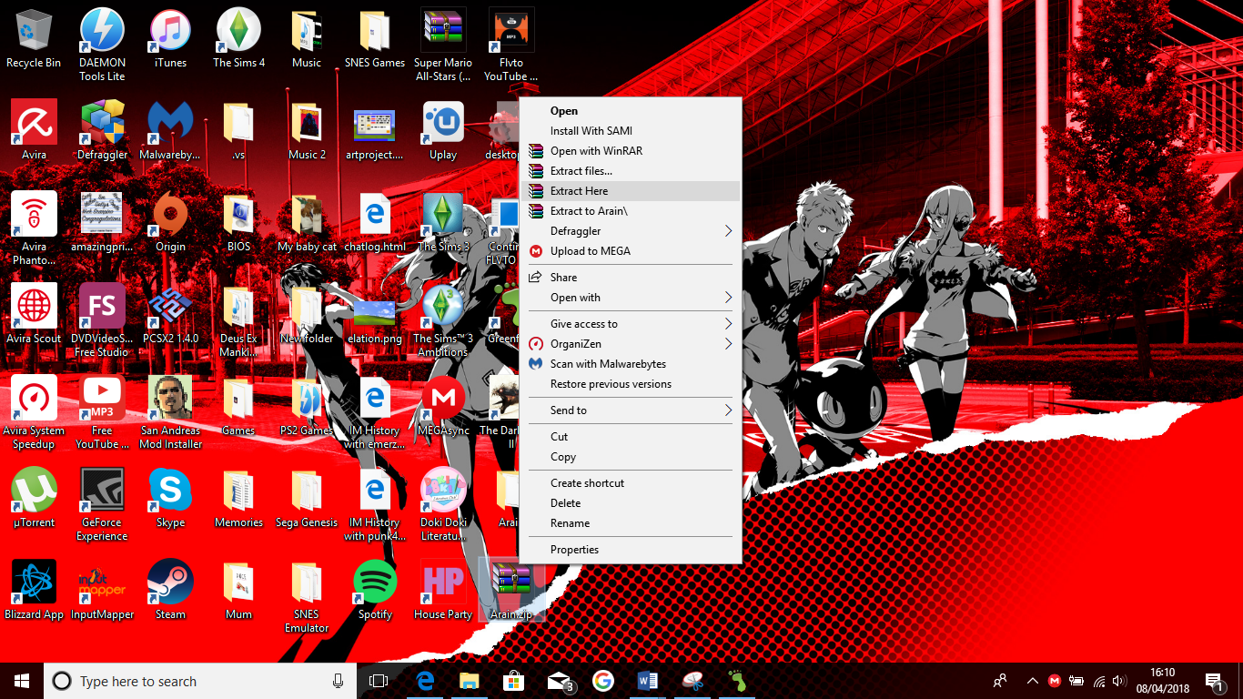

I’ve saved it on my desktop so the next step to do is to extract the files from the zip folder into a normal folder.

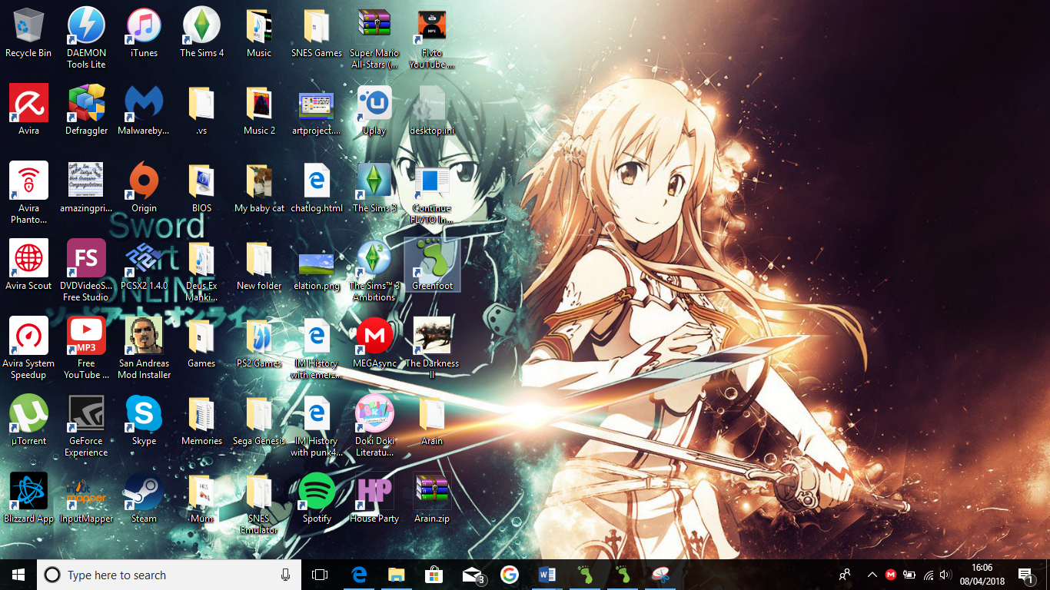

After that’s completed, the next step is to find green foot and open the program

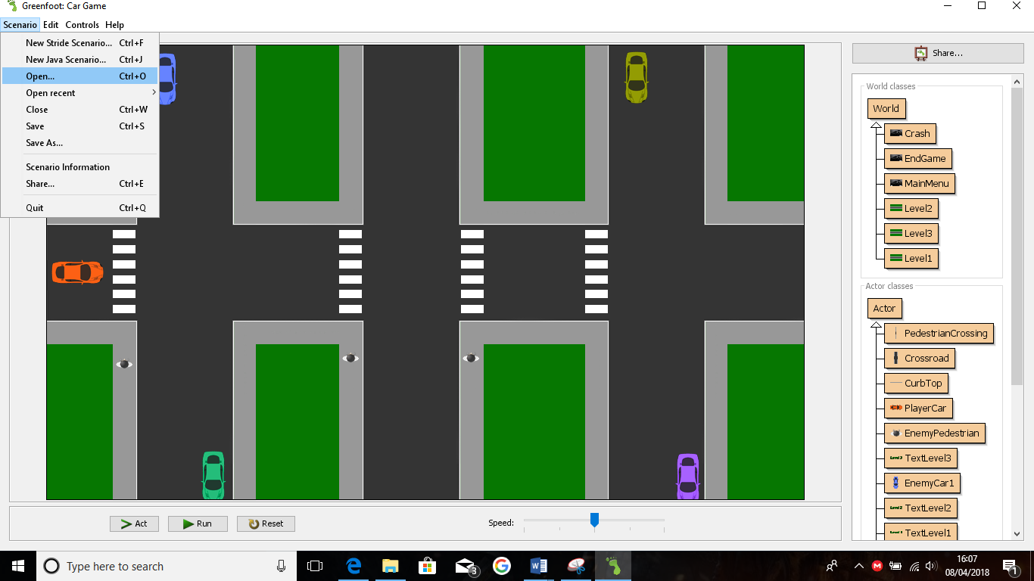

Once the program is open, go to “Scenario” in the top upper left corner of the window and click “Open”.

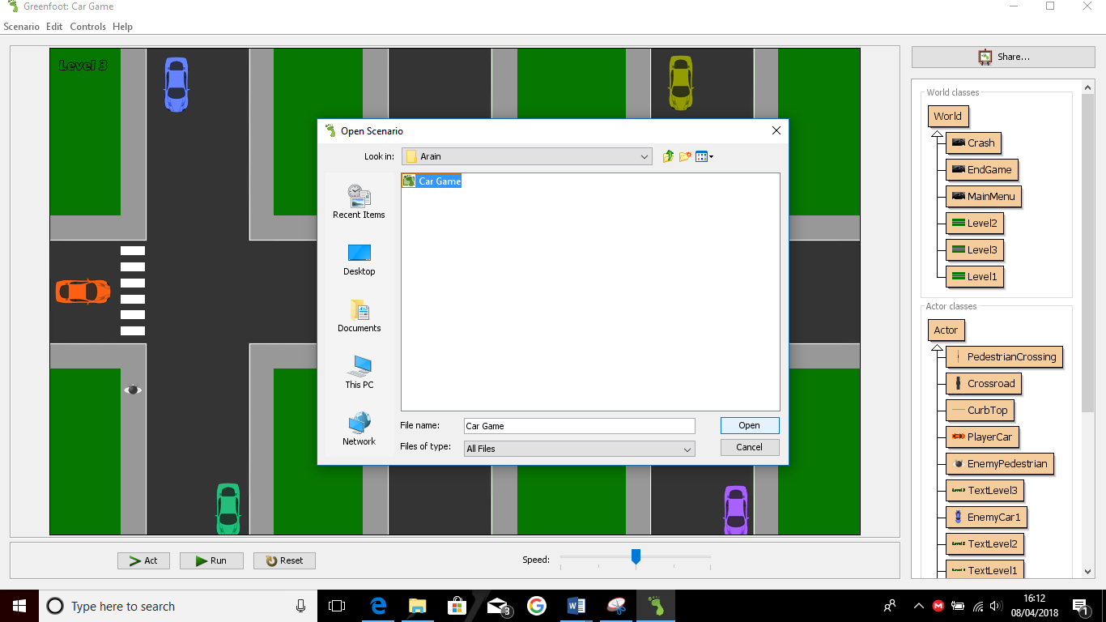

After that, find the folder and open the green foot file found inside the folder.

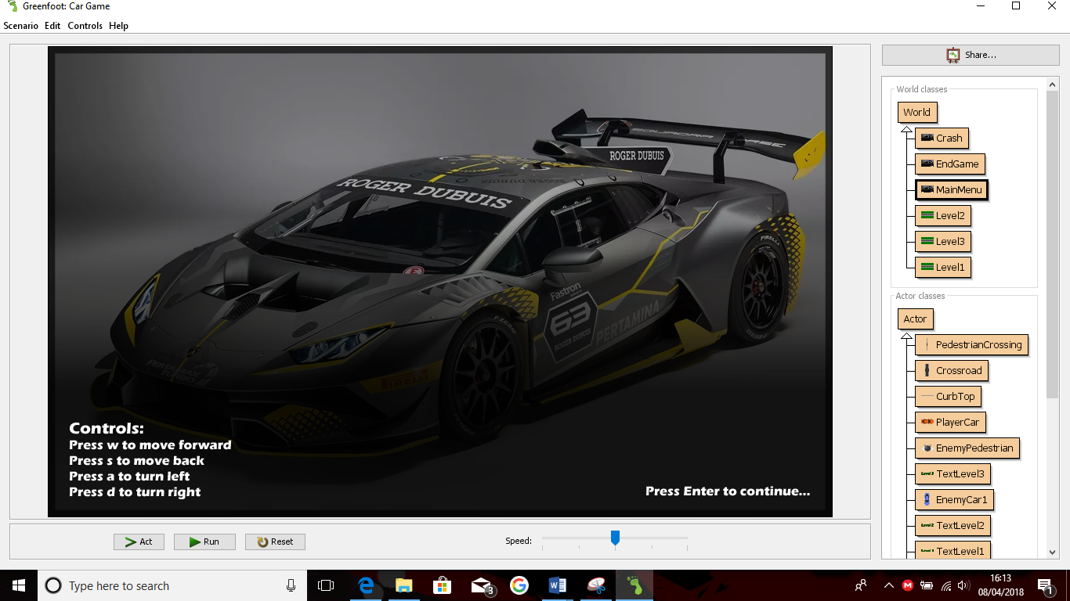

You should be greeted with this screen, when you do, click run at the bottom of the screen and the game will start. The controls are displayed here so you will not feel lost while playing the game, once you read the controls, press enter to start.

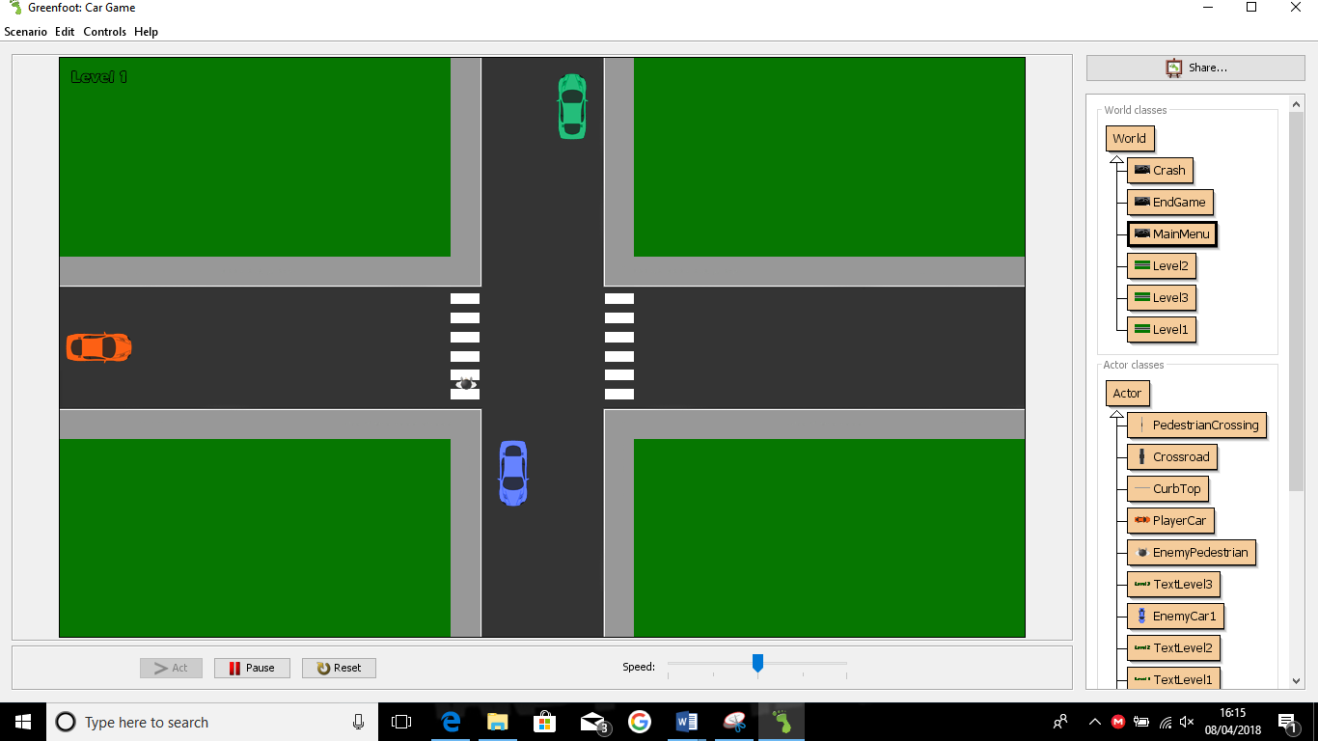

It should put you on this level which is the first one, the objective of the game is to make it across the road without touching any other vehicles or pedestrians.

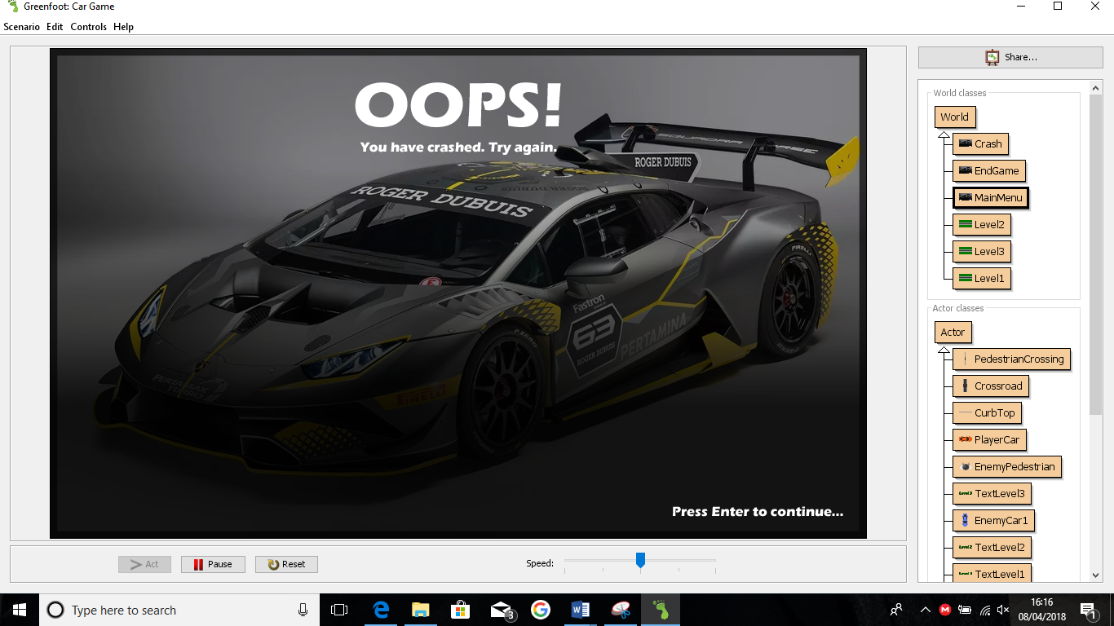

This screen displays when you hit a pedestrian or another vehicle which means this is game over, once this happens, you will be put back onto the first level again.

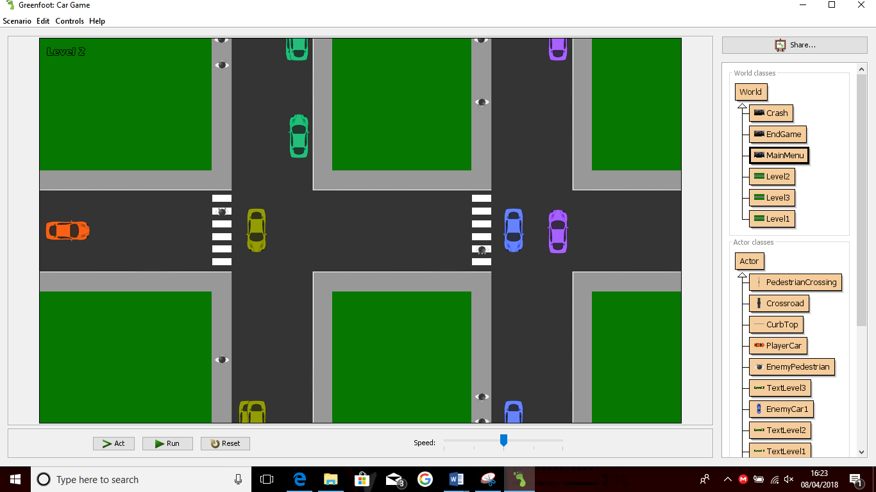

Once you make it across the level, you will be placed into the second level and have the same objective but made slightly harder, so you can sense some progression going on.

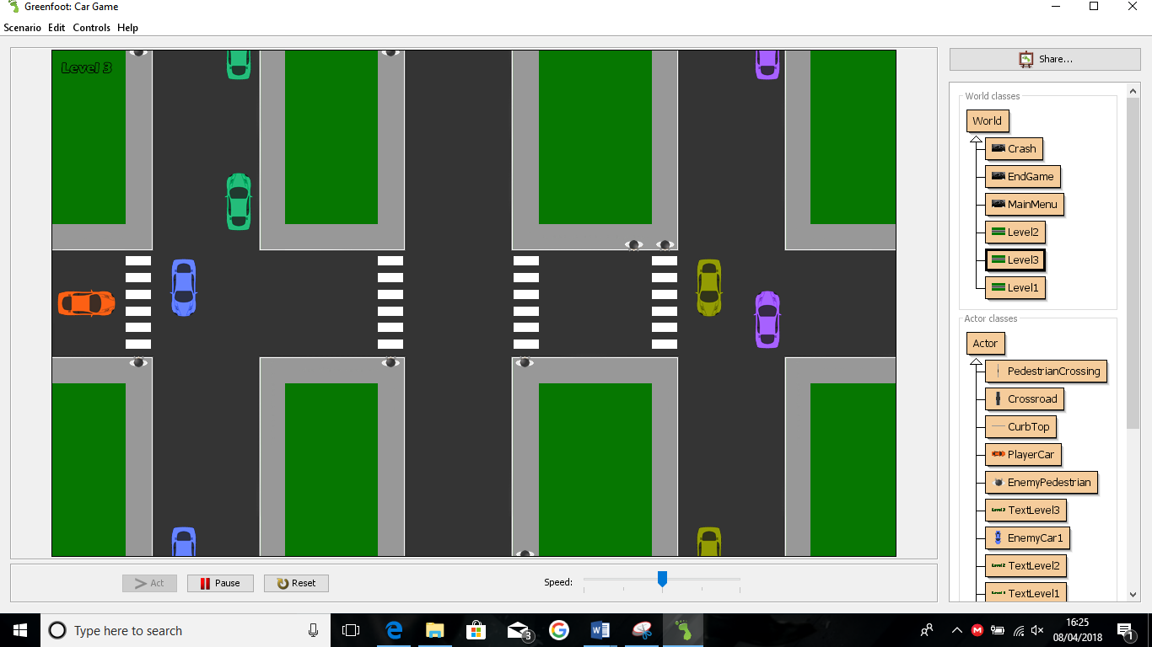

Once you’ve made it past the second level, this is the third and final level which the object is made the same but is made to be slightly harder, when this level is done, there is a special screen just for the winner.

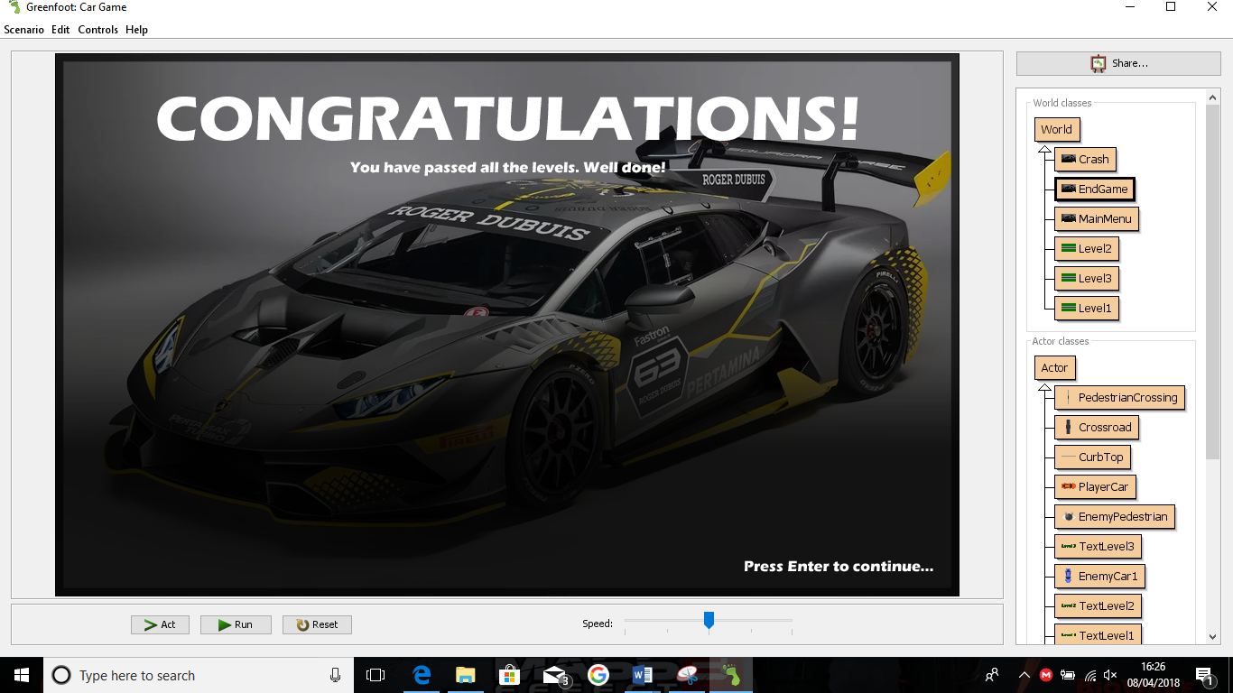

Once you have beaten level 3, you have finished the game and have reached the “Congratulations” screen, once you have finished the game, you can play the game again by pressing enter.

Action Plan

|  |  |  |  |
| --- | --- | --- | --- |
| What did I do? | What time? | Predicted Outcome | Actual Outcome |
| Decide what game I wanted to do | 23rd January 2018 | Decided on either the racing game or the driving game | Decided on the racing game |
| Draw a storyboard for the game | 23rd January 2018 | Finish the storyboard for the game | Finished the story board for the game |
| Do a flow chart for the game | 2nd February 2018 | Finish the flow chart for the game | Finished the flow chart for the game but wasn’t done correctly due to the shapes being incorrect |
| Make an action list for the game | 4th February 2018 | Finish the action list for the game | Finished the action list for the game |
| Make the Input/output Process’ for the game | 4th February 2018 | Finish the Input/output process for the game | Finished the Input/output process for the game |
| Make the Data Dictionary for the game | 4th February 2018 | Finish the Data Dictionary for the game | Finished the Data Dictionary for the game |
| Make the first level for the game | 13th February 2018 – 17th February 2018 | Finish making the first level for the game | Finished making the first level for the game |
| Make the second level for the game | 19th February 2018- 21st February 2018 | Finish making the second level for the game | Finished making the second level for the game |
| Make the third level for the game | 23rd February 2018- 25th February 2018 | Finish making the third level for the game | Finished making the third level for the game |
| Make a start screen and a congratulations screen | 26th February 2018 | Finish both of the screens | Finished both of the screens |

When I performed these tasks, nearly everything went according to plan except for the flow chart that was incorrectly done, when I found out how to do it properly, I changed the shapes to the correct ones and placed the entities to the right position and also placing the arrows in the right directions. A problem I ran into while developing the game was the time limits that had occurred because on the first level, I had to start from scratch which meant I had to do the cars in the right place and also doing the world which is difficult but after the first level was done, doing the world in the next 2 levels were easier due to the world already being set and also if I wanted to add additional crossroads, I could copy and paste the crossroad and place it in a position where it would be able to make the game fair, the only hard part in these levels were doing the coding for the AI on where they would spawn and how they would appear on the screen too.